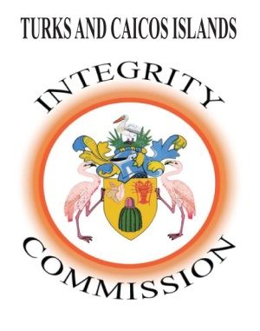
THE TCI INTEGRITY COMMISSION
ENGAGEMENT OF A HUMAN RESOURCE CONSULTANT
SUMMARY:
The Integrity Commission of the Turks and Caicos Islands is seeking to hire a Human Resource Specialist for a short-term consultancy to review the current HR functions, policies, protocols and resources within the Commission; and to update, make recommendations, create and document same, as necessary.

KEY ASSIGNMENTS:

- Meet with staff (14) individually to review and document – respective competencies, responsibilities, job descriptions, challenges and needs.
- Review and conduct an audit of current documents, practices, policies, guidelines, manuals and handbooks on HR related matters, and recommend revisions and adaptions and update as necessary.
- Update the existing organizational chart.
- Review and assess salary scales and contract terms for staff.
- Conduct an audit of the current staff performance appraisal system and recommend revisions, adaptations and update as necessary.
- Review, update, amend and create as necessary - standard forms for employees, contracts and other HR related documents.
- Modernize the filing system for employees’ personal records.
- Compile a list of needed resources.
- Work with Management to identify staffing requirements.
- Propose staff welfare and motivational programmes aimed at increasing employee satisfaction and maximizing the organization’s Mission.
- Assess current training needs and recommend respective training opportunities.
- Review and assess current training policy and provide recommendations, revisions, adaptation and update as necessary.
- Review current procedures for grievances and conflict resolution: make and document recommendations and changes as necessary.
- Any other mutually agreed assignments.

QUALIFICATIONS:

- Bachelor’s Degree in Human Resource Management/Public Sector Management is essential.
  - Professional Human Resource Certification to the level of SPHR or HRMP would be an asset.
  - A Master’s Degree with concentration in Human Resource Management would be an asset.

EXPERIENCE:
- Eight to ten (8-10) years experience in the field of Human Resource Management, with at least five (5) years at a managerial level.

Remuneration
- Contract period is three (3) months
- $20,000
- Travel between Grand Turk and Providenciales - including Accommodations and Subsistence, as necessary.

Location
Office Space will be provided at the Commission’s offices in both Providenciales and Grand Turk, as necessary. (The offices are currently operating under strict Covid19 Protocols)
The successful applicant will report to the Director of the Integrity Commission.
Requisite Knowledge
Applicants are required to be knowledgeable of the Integrity Commission Ordinance, the TCI Public Service Handbook, and the TCI Public Service Ordinance.
Application Procedure
Applications must be submitted to the Secretary, TCI Integrity Commission either by email, fax, or mail. The application must include a cover letter, proof of qualifications, a curriculum vitae, and the names and contacts of two referees.
Contact details are: e-mail: secretary@integritycommission.tc; or Info@integritycommission.tc ; Tel. 946-1941; Fax. 946-1355.
Direct mail should be addressed to Mrs. Wanda Ariza, Secretary, The Integrity Commission, Franklyn Missick Building, Church Folly, Grand Turk, Turks and Caicos Islands.

Please note that only applicants selected for an interview will be notified.

The Deadline for the Submission of Applications is 5th March 2021

